

This should change colour and it should be Spa not spa

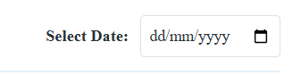

This should be more visible, please dont know that they have to choose a date, showcase it in a way that people should know that they should choose a date, like in a search bar.

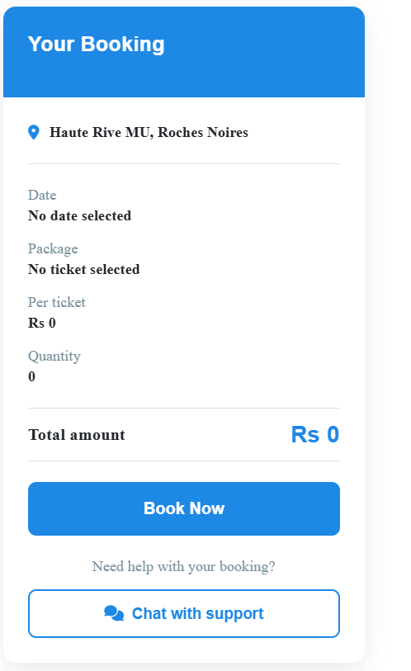

To change colour

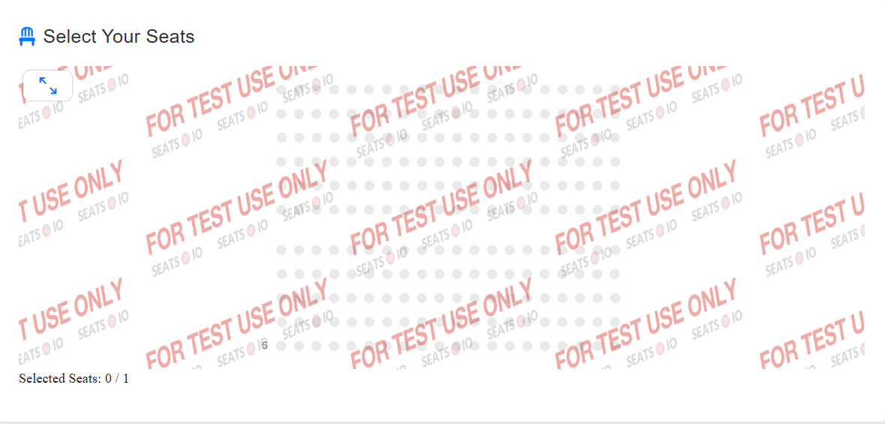

This should not be here

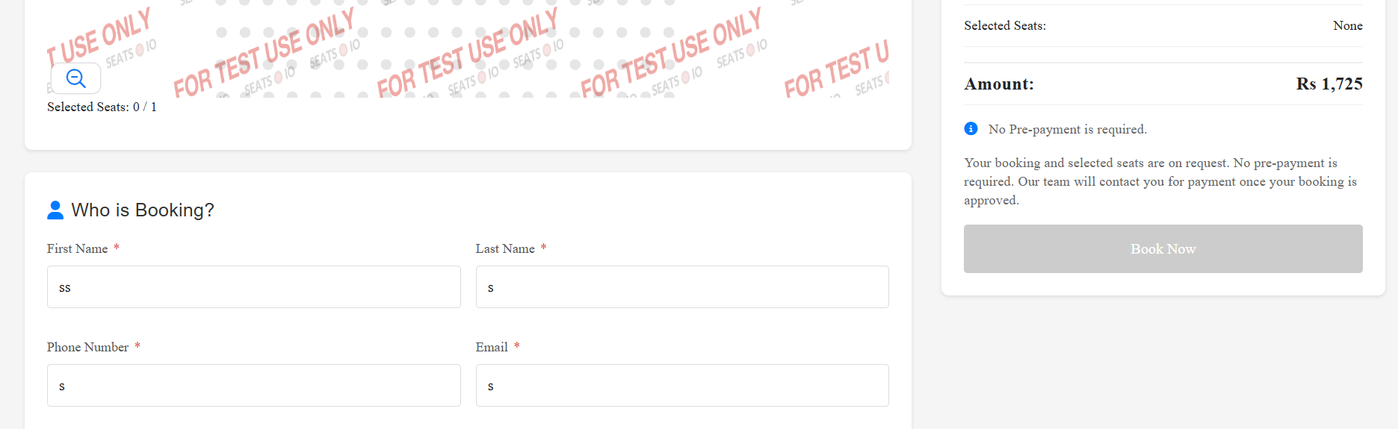

I am not being able to do the booking, it shows me that i should select a seat. It does not make sense

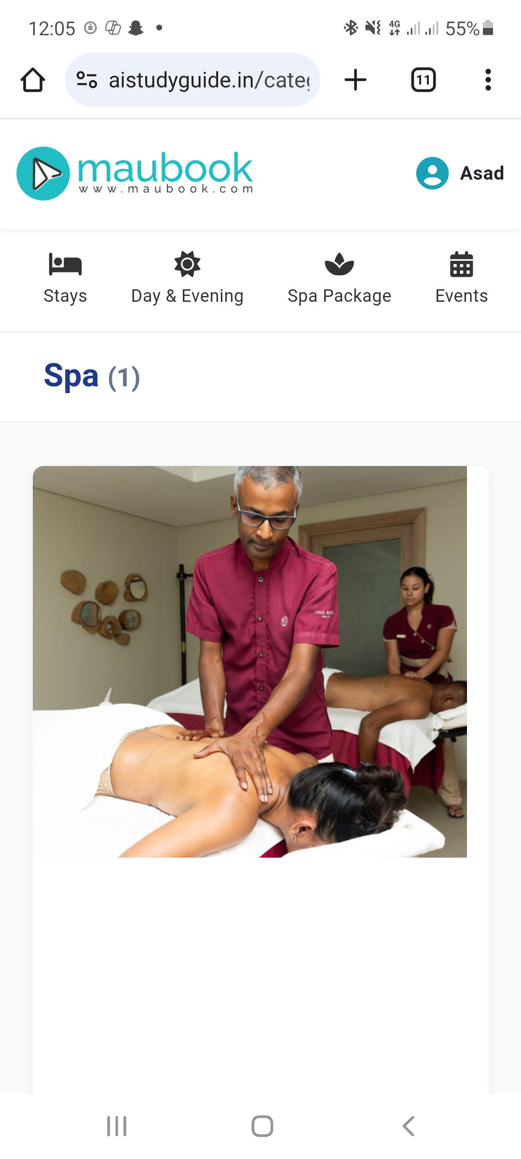

Its not mobile friendly, you can not event see the option to book